Advanced Games Engine Creation
Introduction to 3D Programming using OpenGL

In this practical you will
- Review using SDL and the module framework
- Consider how OpenGL can be used within the framework
- Explore GLUT functions to display standard shapes

1. Download, compile and run the OpenGL_SDL Base Project framework.

2 Identify the different components of the framework and their function. Try to relate them to the UML class diagram shown at the end of this document. Your tutor will discuss this in the practical session.

3. Identify the code that sets up Level 1 and renders the triangle. How does it compare to the code you used Games Engine Creation to set up and draw an image? Your tutor will discuss with you the functionality of each line.

4. Comment out the triangle-drawing code and replace it with the lines:

glColor3f(0.0f, 0.0f, 0.0f);
glutWireTeapot(3.0f);

Run the program – what do you see? Try specifying a different colour for the teapot and the background (clear colour).

5. Try out different GLUT drawing functions which have the following prototypes:

- glutWireSphere(GLdouble radius, GLint slices, GLint stacks);
- glutWireCube(GLdouble size);
- glutWireTorus(GLdouble innerRadius, GLdouble outerRadius, GLint nsides, GLint rings);
- glutWireIcosahedron();
- glutWireOctahedron();
- glutWireTetrahedron();
- glutWireDodecahedron();
- glutWireCone(GLdouble radius, GLdouble height, GLint slices, GLint stacks);
- glutWireTeapot(GLdouble size);

Seehttp://www.opengl.org/resources/libraries/glut/spec3/node80.html#SECTION000120000000000000000 for documentation of these functions

7. Each of the GLUT functions above has a solid-fill alternative, such as

glutSolidTeapot(3.0f);

Try rendering a solid teapot. What does it look like? Later in the module we will learn how to specify and use perspective and lighting to realistically render 3D objects.

8. Comment out the shape-drawing code and uncomment the triangle drawing code.

glBegin(GL_TRIANGLES);
glColor3f(1.0f, 0.0f, 0.0f);
glVertex3f(2.0f, 2.5f, -1.0f);
glColor3f(0.0f, 1.0f, 0.0f);
glVertex3f(-3.5f, -2.5f, -1.0f);
glColor3f(0.0f, 0.0f, 1.0f);
glVertex3f(2.0f, -4.0f, 0.0f);
glEnd();

Run your program again and ensure the triangle displays as expected.

Experiment with changing the vertex positions and colours.

Try drawing a line instead of a triangle by starting the sequence with glBegin(GL_LINE_STRIP) . Add extra vertices to draw a jagged line.

See https://www.opengl.org/sdk/docs/man2/xhtml/glBegin.xml for more possibilities.

9. Write a function to draw a teapot (or a sphere, or another shape) of a given size and color. Call it from your Render method multiple times with different parameters.

Notice that although you can specify and render multiple objects, they will all be centered on the same location and have the same orientation. Over the next few weeks we will learn how we can scale, rotate, and translate objects to place them in different locations in the scene.

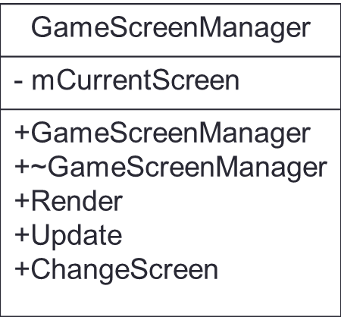
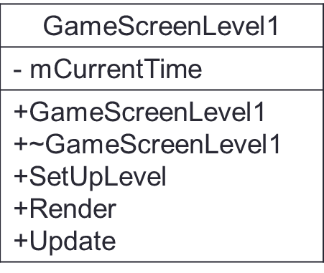
1
1
Source
// global pointers to SDL objects
+main
+InitSDL
+CloseSDL
+Render
+Update
GameScreen

(clear colour)oundto the UML class diagram shown at the end of this document.l work, doing the suggested reading, and +GameScreen
+~GameScreen
+Render
+Update
Class diagram of the OpenGL_SDL project

